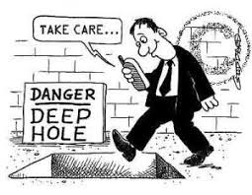
Texting while walking:

Please write your answers to the following questions before reading the article:
- Do you think it is dangerous to text while walking?
- What are the dangers of texting while walking?
Now read the article located at:
https://www.usatoday.com/story/news/2016/03/08/pedestrian-fatalities-surge-10-percent/81483294/
- What is the opinion of the author of the article about texting while walking? What does it do to the person who is walking?
- What are other factors mentioned in the article which add to the number of pedestrians who are killed in accidents?
For a bit of humor, watch this brief video:
https://www.youtube.com/watch?v=ZXYY_ep5Nh0

- Write at least a paragraph containing your reaction to this assignment.

